













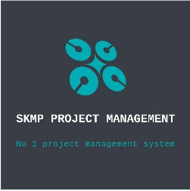



SKMP GROUP PUBLIC
TEMPLET 30,JAN,2025
[BALASORE,ODISHA] [SKMP INFOTECH HEAD OFFICE BALASORE POLISH LINE BALASORE ] | OUR COMPANYS  - SKMP INFOTECH&FOUDATION  - SKMP WEBDEVLOPEMENT  - SKMP PROJECT MANGEMENT  - SKMP ARTS ACADEMY  SERVICE  OUR HELPLINE IS AVAILABLE DURING ONLINE WORKING HOURS: 7:00 AM TO 4:55 PM MONDAY TO SATURDAY  WE PROVIDE  BEST SERVICE  BEST QUALITY SERVICE  SEO OPTIMIZATION  HELP TO BUSINESS GROW
[+91-8596048857]
[SKMPHELPLINE@GMAIL.COM][ SKMPCOMPANY@GMAIL.COM
]
[https://uqzpr8pm2c24p2fpksmuiw.on.drv.tw/SKMP%20INFOTECH%20TECHNOLOGIES/]





OWNERSHIP
[ SKMP GROUP FOUNDED BY MR SUZEN KU MOHANTY IN 2016]

REFERENCE
[BALASORE,ODISHA] [SKMP INFOTECH HEAD OFFICE BALASORE POLISH LINE BALASORE]

